USB PROTOCOL BASICS

TERMINOLOGIES :
Terminology | Explanation
USB | UNIVERRSAL SERIAL BUS
NRZ | Non-Return-to-Zero encoding
PU Resistor | Pull up resistor
PD Resistor | Pull down resitor
DIFF1 | Differential '1'
DIFF0 | Differential '0'
SE0 | Single-ended zero:
SE1 | Single-ended one:
Endpoints | Virtual communication channels in USB, numbered from 0 to 15, used for different types of data transfers.
USB Descriptors | Data structures that describe various attributes of a USB device, used by the host to identify and configure the device
USB Standard Class | Categories of USB devices based on functionality, with standard protocols for communication, allowing for generic drivers and broad compatibility.
Enumeration Phase | The process where the host configures a newly connected USB device, involving reset, descriptor requests, and assigning a unique address.

USB as Protocol :
USB is a standardized technology for connecting peripheral devices to a computer or other host device. It allows for the transfer of data and power between devices. The USB protocol is based on host and devices communication : The host initiates and controls communication, while the device responds to the host's requests in the USB protocol.
1-Speed: the communication methods and data transfer rates, which can vary based on the USB version
-Low speed(v1.0)(LS) : 1.5Mb/s -Full speed (FS) : 12Mb/s
-High speed(HS)(v2.0) : 480Mb/s..
v3.0 5Gb/s v3.1 10Gb/s V3.2 20Gb/s
.USB support (127 device/5 hubs) as maximum
USB PORT TYPES
USB ports are physical interfaces on a host device that enable connection and communication with USB peripherals.(will be deeply explained in hardware design document but for now a simple USB port like A/B/micro and mini’s contain Data+,data- ,VCC,GND pins
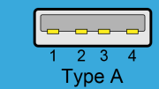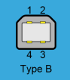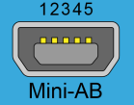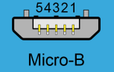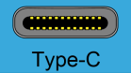
2-PHYSICAL LAYER FLOW :
The physical layer flow in USB defines the electrical and signaling specifications for data transmission between the host and devices over the USB cable.

Bit stuffing: inserting 0 after 6 consecutive 1
NRZ: every 0 you toggle the signal
-Clock accuracy is a MUST (± 0.05% (500 ppm)tolerance for HS and ± 0.25% (2500 ppm) tolerance for FS)(ppm stands for part per million)
3-USB bus states:
USB bus states refer to the various operational conditions of the USB communication link, including states like Idle, Active, Suspend, and Resume.
These states are crucial for the communication and control of USB devices. used to represent different signaling conditions. Upgrade signal quality and reduce noise
3.1-Technical terms:
This part will be deeply explained in hardware design part but for now you need to know :
PULL UP RESISTOR: resistor attached to VCC
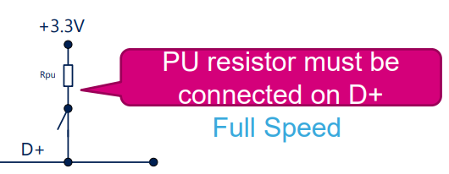

PULL DOWN RESISTOR: resistor attached to the Ground
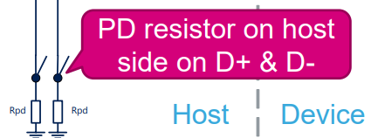
DIFF1 : D+ HIGH , D- LOW Diff0 : D+ LOW ,D-HIGH
SE0 : D+ D- LOW SE1 : D+ D- HIGH
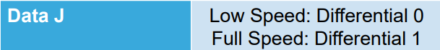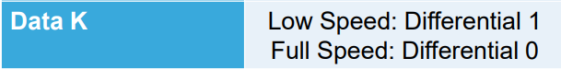
EXAMPLE : Consider a USB device transmitting the binary sequence "1010". The device will alternate between the J-state and K-state as follows:
- '1': J-State - D+ is high, D- is low (Full-Speed USB)
- '0': K-State - D+ is low, D- is high (Full-Speed USB)
- '1': J-State - D+ is high, D- is low (Full-Speed USB)
- '0': K-State - D+ is low, D- is high (Full-Speed USB)
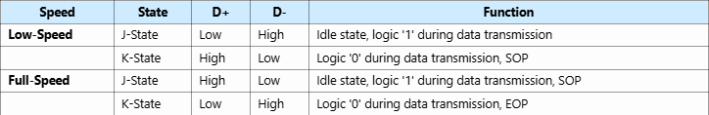
HIGH speed: first a RESET happen by pulling SE0 from 10ms then a FS mode is initiated then high speed handshake happen by sending a special shirp sequence from the host (~very fast signal sequence) and if the device could handle it he returns his own chirp.in HS mode idle state is like LS PU resistor for D- and PD resistor for D+
Practical case : how the USB know that is connected ? and how it communicates
èUSB devices have different layouts for LS/FS/HS on data lines. A device connects to the host with an already set speed. Based on this speed, the host detects a voltage on either the D+ line (for FS/HS) or the D- line (for LS). This voltage change informs the host that a device is connected and indicates its speed. During data transmission, the device alternates between the J-state and K-state to represent binary data. The transition from J-state to K-state or vice versa can also signal control events like SOP and EOP.
USB TRANSFERS
ENDPOINTS?
In USB communication, there are virtual communication channels, also known as endpoints, which are numbered from 0 to 15. These endpoints are categorized into 4 types:
1-Control Endpoints:
Typically, endpoint 0 is designated as the control endpoint.
Maximum Packet Size:Full-Speed (FS) and High-Speed (HS): 64 bytes.
Control endpoints are used for device configuration, command, and status operations.
2-Bulk Endpoints:
Used for large, non-time-critical data transfers.
Maximum Packet Size: Full-Speed (FS): 64 bytes. High-Speed (HS): 1024 bytes.
Bulk transfers are ideal for transferring large amounts of data reliably but without strict timing requirements.
3-Interrupt Endpoints:0
Used for small, time-sensitive data transfers, such as input from a keyboard or mouse.
Maximum Packet Size:Full-Speed (FS): 64 bytes.High-Speed (HS): 1024 bytes.
Interrupt transfers ensure timely delivery of data by polling the endpoint at regular intervals.
4-Isochronous Endpoints:
Used for real-time data transfers, such as audio or video streaming, where timely delivery is more important than error-free delivery.
Maximum Packet Size:Full-Speed (FS): 1023 bytes.High-Speed (HS): 1024 bytes.
Isochronous transfers provide guaranteed bandwidth , but they don’t do error correction.
How to set it :
Bit 7(left) : 1 for IN and 0 for OUT ) Bit ((4-6) : usually 0
Bit 0x00 : number on endpoints used on binary with 0000 endpoint 0 and 1111 endpoint 15
Packets structure :
Packet structure are like words . you use them to build a phrase to do a full successful meaningful communication between host and device
- token packets : for data direction (contain PID and CRC for data verification)
-datapacket : contain the data payload (max1024 bytes verified by PID (mirroring)and CRC )
-acknowledge packet / handshake packet (ACK NAK STALL NYET)
-ACK : success , NAK : failed , STALL , can’t receive , NYET : wait and resend (HS ONLY)
-(Start Of Frame)SOF packet(packet for isochronous transfers that guard timing)
Send signals in periodicial intervals for time reference (1ms for LS , and 125us for HS)
******Token pack+datapack+handshake pack(acknowledge) +sof (in isochronous)******
USB_DESCRIPTORS
USB descriptors are data structures that describe various attributes of a USB device. They are used by the host to identify and configure the device. There are several types of USB descriptors, each serving a specific purpose.
there are 4 types of descriptors excluding String descriptor
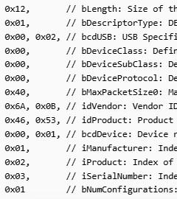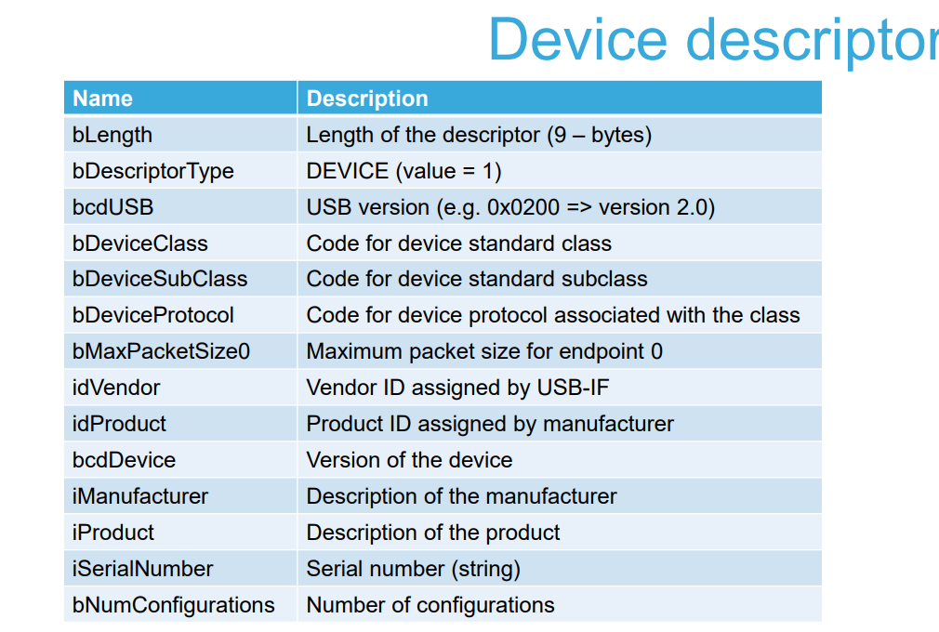
UTILITIES
- Provides general infos about USB device
-Includes fields such as USB version, vendor ID, product ID, device class, and maximum packet size for endpoint 0.

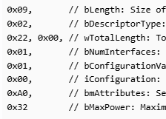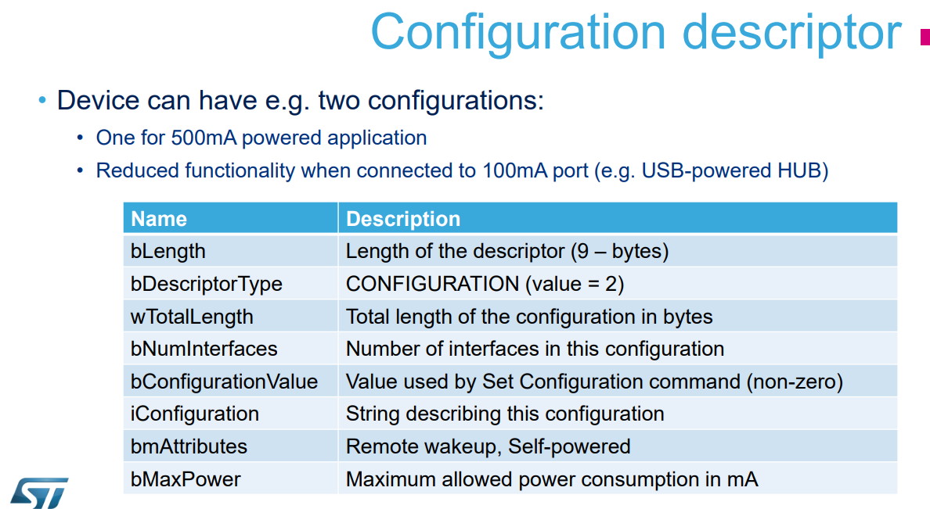
UTILITIES
Describes a specific configuration of the device.
-Includes the number of interfaces, power requirements,

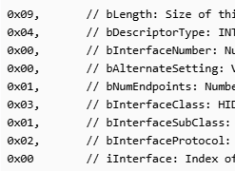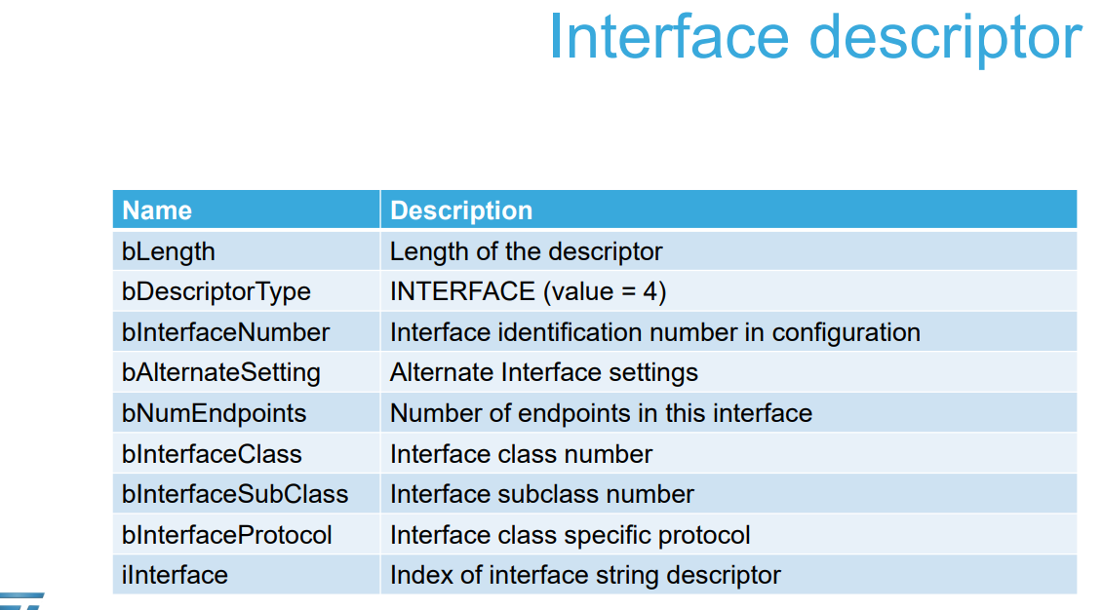
UTILITIES
-Describes a specific interface within a configuration.
-Includes the number of endpoints, interface class, subclass, and protocol

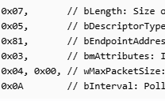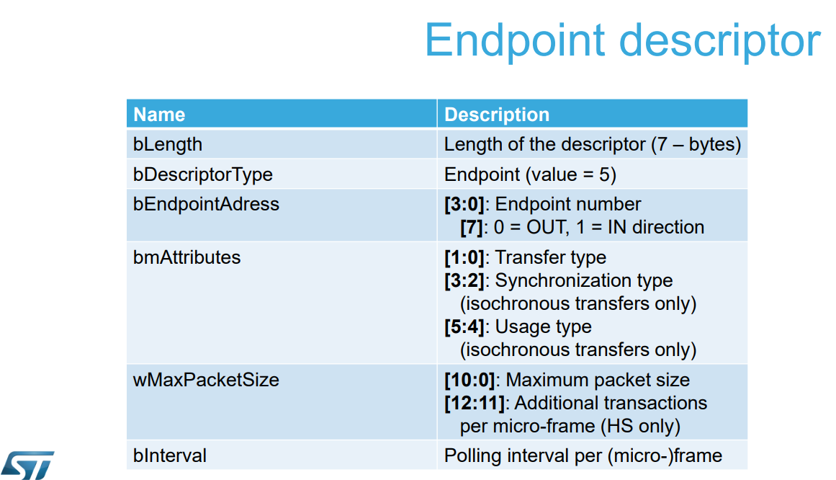
UTILITIES
- Describes an endpoint within an interface.
-Includes endpoint address, attributes, and maximum packet size.

DEVICE QUALIFIER DESCRIPTOR(only FOR HS)
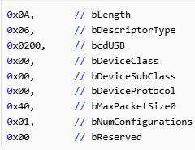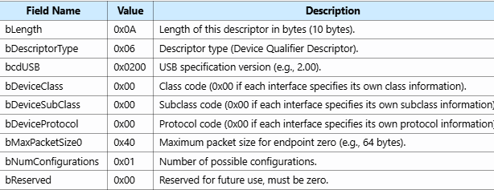
CALL SEQUENCE : the Device Descriptor is the first descriptor the host reads, providing general information about the device, including the number of configurations it supports. The host then requests the Configuration Descriptor, which includes details about the specific configuration, such as the number of interfaces. Each Interface Descriptor within the configuration describes a particular interface, including the number and types of endpoints it uses. Finally, the Endpoint Descriptors provide detailed information about each endpoint, such as their addresses, transfer types, and maximum packet sizes. Additionally, String Descriptors may be used to provide human-readable information like manufacturer and product names.
USB STANDARD CLASS
USB standard classes categorize devices based on their functionality and define standard protocols for communication. This allows operating systems to provide generic drivers for these classes, simplifying device development and ensuring broad compatibility.
USB Standard Class | Examples | Utilities
Human Interface Device (HID) | Keyboards, mice, game controllers | Low-latency, small data transfers; plug-and-play; no additional drivers needed
Mass Storage Class (MSC) | USB flash drives, external hard drives, memory card readers | Bulk transfers for large data blocks; standard SCSI commands for read/write operations
Audio Class | USB microphones, speakers, audio interfaces | Isochronous transfers for real-time audio data; multiple audio streams and synchronization
Communications and CDC Control Class | USB modems, network adapters, serial port devices | Control and data interfaces for network and communication devices; virtual COM ports
Printer Class | USB printers | Bulk transfers for sending print jobs; standard commands for printing operations
Hub Class | USB hubs | Allows multiple USB devices to connect to a single USB port; manages power distribution and device enumeration
Smart Card Class | Smart card readers | Communication with smart cards for authentication and secure transactions
Relation between endpoints and classes
2.1. Example of a HID function
Here’s an example of endpoints that might be declared for an HID class:
- 1 x control endpoint (endpoint 0): Used for standard USB control transfers, such as configuration and enumeration.
- 1 x interrupt IN endpoint: For sending HID reports from the device to the host (for example, mouse movements, keyboard presses). This endpoint is used to send periodic data to the host with minimal latency. The HID descriptor defines the polling interval for this endpoint.
- 1 x interrupt OUT endpoint: For receiving HID reports from the host to the device (for example, LED status for keyboards, feature reports). This endpoint is used to receive data from the host that needs to be processed by the device.
2.2. Example of a CDC virtual communication port function
Here’s an example of endpoints that might be declared for a CDC ACM class implementation (PSTN subclass):
- 1 x bulk IN endpoint: For sending data from the STM32 device to the PC host. Data received over UART is saved in a buffer to be sent. Periodically, a timer callback checks the buffer state. If data is available, it’s transmitted in response to an IN token; otherwise, it’s NAKed.
- 1 x bulk OUT endpoint: For receiving data from the PC host to the STM32 device. Data received through this endpoint is saved in a receive buffer and then transmitted over UART using interrupt mode. Meanwhile, the OUT endpoint is NAKed. Once the transmission is complete, the OUT endpoint is prepared to receive the next packet in the UART transmit callback.
- 1 x interrupt IN endpoint: For setting and getting serial-port parameters. In this example, two requests can be implemented:
  - Set Line: Set the bit rate, number of stop bits, parity, and number of data bits.
  - Get Line: Get the bit rate, number of stop bits, parity, and number of data bits.
  - Other requests (send break, control line state) may be implemented.
2.3. Example of an audio function
Here’s an example of endpoints that might be declared for an audio class:
- 1 x control endpoint (endpoint 0): Handles standard USB control transfers.
- 1 x isochronous IN endpoint: Transfers audio data from the microphone to the host.
- 1 x isochronous OUT endpoint: Transfers audio data from the host to the speaker.

FLOW OF EVENTS WHEN A USB DEVICE IS CONNECTED
- Device Connection Detection:
  - Event: A USB device is physically connected to the host or hub.
  - Action: The device uses a pull-up resistor on the D+ line (for FS/HS) or D- line (for LS)
  - Result: The host detects the voltage change and determines the device's speed.
- USB Reset and Initialization:
  - Event: The host signals a USB reset by sing SE0 for 10ms at least
  - Action: The device reinitializes and prepares for enumeration.
  - Result: The device enters the default state, ready for communication.
- Enumeration:
  - Event: The host begins the enumeration process to configure the device.
  - Action: The host sends a series of control transfers to request the device descriptor, configuration descriptor, and other necessary descriptors.
  - Result: The host assigns a unique address to the device and configures it
- Data Transfer Preparation:
  - Event: The host and device prepare for data transfer.
  - Action: The host sets up the endpoints as described in the configuration…
  - Result: The device is ready to send and receive data through the endpoints.
- Data Packet Transmission:
  - Event: The host or device initiates a data transfer.
  - Action: The data packet is organized into fields (e.g., PID, address, data payload, CRC) and encoded using bit stuffing and NRZI encoding.
  - Result: The encoded data is transmitted as differential signals on the D+,D-
- Differential Signaling:
  - Event: The data packet is transmitted over the USB bus.
  - Action: The electrical signals represent the data bits using NRZI encoding
  - Result: The differential signals are received by the host or device.
- Data Reception and Decoding:
  - Event: The host or device receives the differential signals.
  - Action: The received signals are decoded using NRZI, and stuffed bits are removed.
  - Result: The original data packet is reconstructed.
- Data Analysis and Processing:
  - Event: The host or device processes the received data packet.
  - Action: The CRC is checked to ensure data integrity. The packet is then processed according to the USB protocol (e.g., control, bulk, interrupt, or isochronous..
  - Result: The data is successfully transferred and processed)

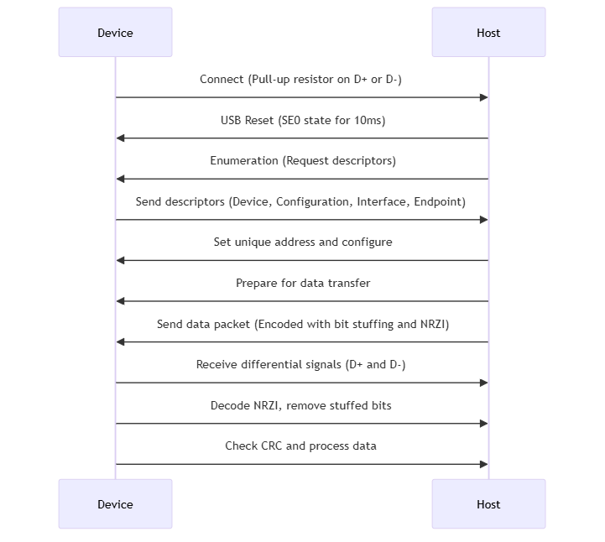
**enumeration phase : reset-sequence of desc request-unic address-

